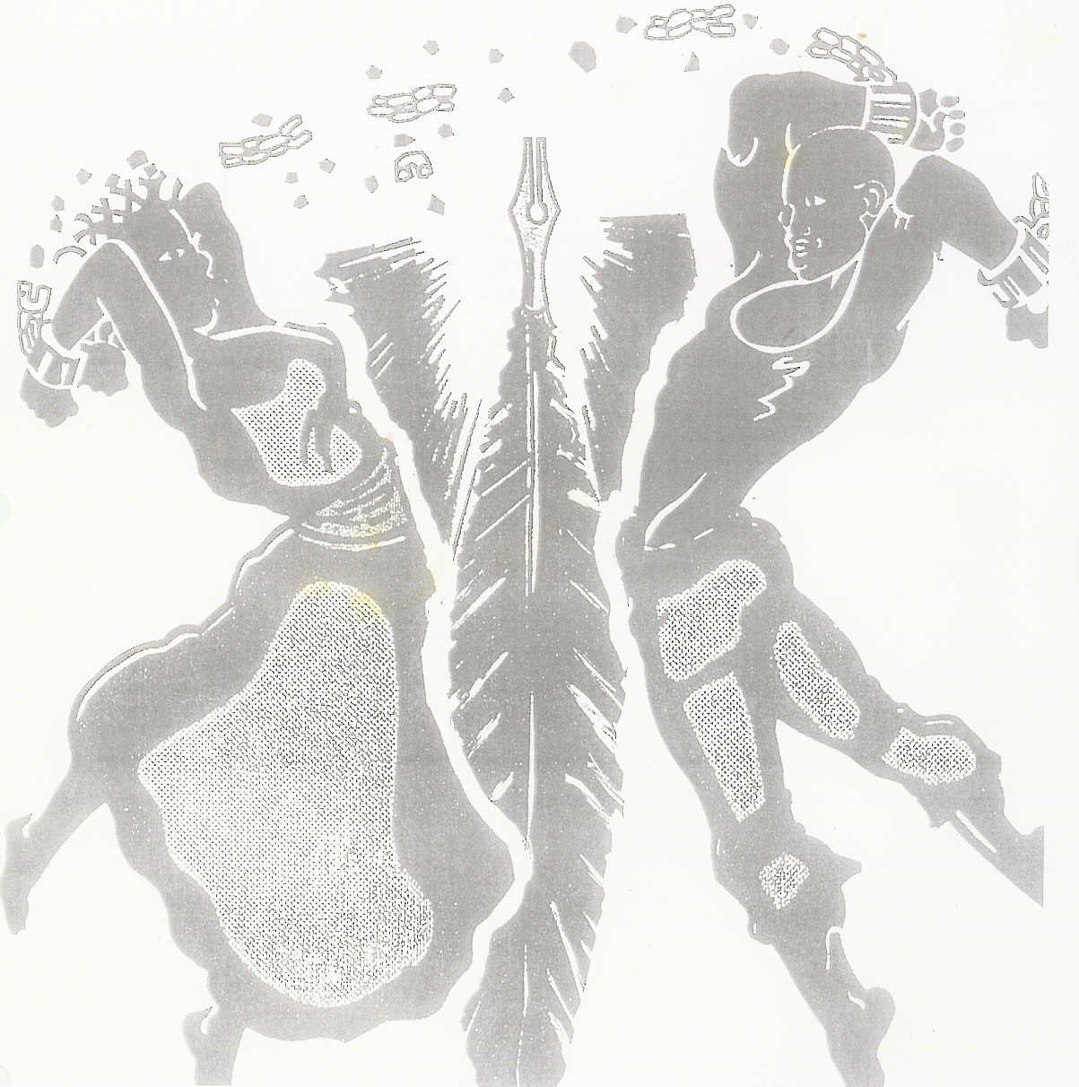
2012 Natural Hair Competition & Style Show

1511 E. Livingston Avenue Columbus Ohio 43205 (614 258-4633)
*Win $1,500!!!
INFORMATION, RULES & GUIDELINES

This is A Total Look Competition!!!!

The entry fee for the competition is $499 and is limited to the first 16 entries (8 Individual Stylists and 8 Salons). This fee covers entry to competition and listing on the JuneteenthOhio website as a participant with the opportunity to win the $1,500 prize!!! Alternate participation for stage time only is $299 and includes listing as a participant on the JuneteenthOhio website. All participants may also add any size ad in the event booklet at the prices listed on the form; those competing may also select the package deal which adds a vendor booth for the weekend (3 days) and a full-page ad in the event booklet for a total cost of $1,000. Everyone will receive a confirmation letter after registration and payment are received and a temporary parking pass for the event participation time; will include entire weekend parking pass for those selecting the package plan. The theme for all competitions is “Back To Natural Beauty”. That means we are looking for styles that show “Whatever we’ve misplaced, forgotten, forgone or have been stripped of can be reclaimed in natural beauty.” We are looking for creativity and flawless skills at their best for natural styles that can be worn both casually and in the workplace. Models must have no chemical straighteners/alterations to her/his hair; hair may be flat ironed and permanent color, semi-permanent color, light colors, natural hair extensions, chalks and sprays are allowed. Hairpieces are allowed but must not cover more than 1/3 of the head. Hair weaves may be used. Hair ornaments must be made of at least 85% hair (human or synthetic). The entire design must be made of at least 85% hair. Prep time will be limited to 2 hours. The hairstyle should be no more than ¾ completed prior to entering the prep area.

There is a limit of one model stylists. Models can be female or male. Models, stylists and make-up artists must sign the release form; a parent or guardian must also sign the model release for models under the age of 18; model releases will be provided in your competition packet that will be sent to you once your registration is received. The model can’t be the stylist nor can the stylist be the model. Model and stylist may work together to do make-up or a separate make-up artist may be used. During stage presentation, your model will not be judged, but judges will be looking for a complete package. That means the model’s attire should tie-in with the hairstyle and the hairstyle and attire must compliment each other. Competitor will be judged on overall neatness, technique, creativity and artistic design. Judging will be done on a visual basis only. Finalists (top two individual stylists and top two salons) will be selected and will re-compete to select he grand prize winners! The decision of the judges will be final.

Only the models, stylist and make-up artists will be allowed in the competition area and prep room. Competitor must supply their own tools needed to style their model’s hair (mirrors, capes, clippers, combs, shears, products, etc.); electricity and tables and chairs will be provided. Not following rules and tardiness will result in disqualification.

Competitors, models and make-up artists report to prep/pre-judging area; you must all check-in together. This is the allotted time to style, apply models make-up; models should be dressed in competition attire upon arrival. NOTE: Model numbers will be given at check-in. Check in time does not guarantee your model’s number; checking in first does not guarantee that your model will have #1.

NOTE: Skits included with your presentation are welcome. Limit your presentation time to 3 minutes for stylists and stage time only participant. Each competitor will be introduced by the Emcee, who will describe their hairstyle to the audience as well as to the judges. Stylists should prepare complete commentary for emcee to read, which should include salon/stylist name, model’s name and description of your hairstyle. Please provide any music you want played during your presentation on a CD; your music for the presentation should be the only thing on the CD. Music selection must be appropriate for all ages.

The International 30-point scoring system will be used to select the winners. The decision of the judges is final.

30 POINT JUDGING SYSTEM (less than 16 competitors)

30 points (best stylist or salon)
29 points (2nd best stylist or salon)
28 points (3rd best stylist or salon)
27 points (4th best stylist or salon)
26 points (5th best stylist or salon)
25 points (6th best stylist or salon)
20-23 points (remaining stylists or salons)

Important: Show management reserves the right of final interpretation of rules and guidelines for the competition. Early registration is vital. Finalists will be selected and will then re-compete to select overall winner. Cash prize is issued on the amount of entry fees received for the competition. *There must be 8 entries in the competition category (individual or salon) to award full $1,500. If the minimum amount of entries is not met, cash pries will be adjusted based on the amount of entry fees for the competition. Winning salon or individual receives the cash prize and an opportunity to join the Official Hairstyling Team for the 2013 international pageant competition for Ubuntu Pageants International, planned for February 2013 in Columbus, OH. All participants receive a trophy and listing on JuneteenthOhio Festival website. Cash prize and trophies will be awarded 30 days after event for public pictures, press releases and payments to be processed. In case of rain, the event will be moved inside. If a contestant is disqualified for any reason, no refund will be issued. No exceptions!!! Any questions should to be directed to the JuneteenthOhio Festival by calling 614-258-4633 or by email to Juneteenthohio@fuse.net.

By signing this form, you are acknowledging that you are full aware of and understand all procedures for the competition.

Good Luck!

Model/Stylist Signature __________________________________________________ Date __________

JuneteenthOhio Rep Signature _____________________________________________ Date __________

2012 Natural Hair Competition & Style Show

1511 E. Livingston Avenue Columbus Ohio 43205 (614 258-4633)
Sales Associate _Vanessa King__
Entry # ____________________
Approval ___________________
Win $1,500!!!

REGISISTRATION FORM

Salon or Individual Stylist Name: ____________________________________________________________________

Address: ________________________________________________________________________________________

City: _________________________________________ State: ____________ Zip: ____________

Telephone: ________________________________ Evening/Cell: _______________________________

Email ________________________________________________________________________________________________

Entry Selection: Individual Stylist _____ Salon Team (maximum of 5 stylists) _____

**Competition Fee: **Stage Time Only Fee: Event Booklet Ad:
___ $499 ___ $299 ___Full-Page $500 ___ ½-Page $250 ___ ¼-Page $125

Complete Competition Package (Includes Competition Entry, Full-Page Booklet Ad, Vendor Booth for Weekend and Listing on JuneteenthOhio Website as a Participant)
___ $1,000

Register Early!
Register early to guarantee participation! There is a limit of 16 entries (8 individual stylist and 8 entries salons) for competition; others may enter to receive stage time only. Each Stylist must sign the registration form. Please complete the form and mail to the address below. Pre-registration must be entered on or before June 1, 2012. Space is limited to the 8 salons and first 8 individual stylists registered for participation in competition. There’s a limit of one model per stylist. Please contact us to see if spaces are filled prior to submitting registration. Alternate participating for stage time, without competition, is available once spaces are filled. The competition will be held from 3pm – 6pm on Sunday, June 17, 2012 at the JuneteenthOhio Festival’s Main Stage, located at Franklin Pack in Columbus, OH. Prep time will be 2 hours prior to competition time. You should arrive at noon to check in.

Deposit Amounts:
Entry fee deposit is $499 for competition entries; fee includes participation and listing on the JuneteenthOhio website as an event participant with an opportunity to win $1,500 prize if selected as the Best Individual Stylist or Best Salon!!! The fee is $299 for those with stage time only and includes 3 minutes of stage time and listing on the JuneteenthOhio website as a participant.** Deposits are non-refundable and non-transferable. Early registration is highly recommended to guarantee entry into competition. Payment must be made by money order or a cashier’s check made payable to “JuneteenthOhio Festival” or by credit card with a 4% card processing fee. Each stylist or salon team member must sign the official entry application and submit them along with the appropriate entry fee to the address above. In doing so, the competitors agree to abide by any and all decisions of the competition judges. The decision of the judges is final!

Important: No refunds will be given. The event goes on rain or shine. In case of rain, the event will be moved inside. Show management reserves the right of final interpretation of the rules and regulations in all competitions.

I wish to officially enter the JuneteethOhio Festival Natural Hair Competition & Style Show. I will abide by all printed or verbal rules and regulations. I understand that all contest committee decisions are final. Entries will be on a first-come, first-serve basis. I also understand that the competition is based on stylist participation and may be changed or altered at the decision of the competition chairman. In either case, my entry fee will not be refunded and I will have no further redress; in case of rain, the event will be moved inside.

I have read and understand the procedures for entry into the JuneteenthOhio Natural Hair Competition.

Stylist/Salon Rep Signature: _______________________________________ Printed Name & Date: __________________________

JuneteenthOhio Rep Signature: _____________________________________ Printed Name & Date: __________________________

Return Form and Payment to:
Official Use Only:

Received By: ________________________________

Date: ________/________/________
Alkebulan, Inc.
JuneteenthOhio Festival
1511 E. Livingston Ave
Columbus, OH 43205
ATTN: Hair Show Submission
2012 Natural Hair Competition & Style Show

1511 E. Livingston Avenue Columbus Ohio 43205 (614 258-4633)
Sales Associate _Vanessa King__

Entry # ___________________

Approval __________________
MODEL RELEASE

I, _____________________________________________ do hereby give to the JuneteenthOhio Festival and it’s assigns, licensees, successors in interest, legal representatives, and heirs the irrevocable right to use my name (or any fictional name), picture, portrait, or photograph in all forms and in all media and in all manners, without any restriction as to changes or alterations (including but not limited to composite or distorted representations or derivative works made in any medium) for advertising, trade, promotion, exhibition, or any other lawful purposes, and I waive any right to inspect or approve the photograph(s) or finished version(s) incorporating the photograph(s), including written copy that may be created and appear in connection therewith.
I hereby release and agree to hold harmless the JuneteenthOhio Festival, his or her assigns, licensees, successors in interest, legal representatives and heirs from any liability by virtue of any blurring, distortion, alteration, optical illusion, or use in composite form whether intentional or otherwise, that may occur or be produced in the taking of the photographs, or in any processing tending toward the completion of the finished product, unless it can be shown that they and the publication thereof were maliciously caused, produced, and published solely for the purpose of subjecting me to conspicuous ridicule, scandal, reproach, scorn, and indignity. I agree that the JuneteenthOhio Festival owns the copyright in these photographs and I hereby waive any claims I may have based on any usage of the photographs or works derived therefrom, including but not limited to claims for either invasion of privacy or libel. I am of full age and competent to sign this release. I agree that this release shall be binding on me, my legal representatives, heirs, and assigns.
I have read this release and am fully familiar with its contents.
Printed Name of Model/Stylist: ____________________________________________________________
Signature: _____________________________________________________________________________
Date: _____________________, 20 _____
Consent (if applicable):
I am the parent or guardian of the minor named above and I have the legal authority to execute the above release. I approve the foregoing and waive any rights in the premises.
Printed Name of Parent or Guardian: ________________________________________________________
Signature of Parent or Guardian: ___________________________________________________________
Date: _____________________, 20 _____
Official Use Only:

Received By: ________________________________________

Date: ________/________/________

2012 Natural Hair Competition & Style Show

1511 E. Livingston Avenue Columbus Ohio 43205 (614 258-4633)
Sales Associate _Vanessa King
Entry # ___________________
Approval _________________

CREDIT CARD AUTHORIZATION FORM

Name on Card: __________________________________________________________

Billing Address of Card:
Street Address______________________________________________________

City, State, Zip Code_________________________________________________

Email Address: ____________________________________________________________

Card Type: ( ) VISA ( ) MasterCard ( ) American Express ( ) Discover

Card Number: __________________________________________________________

Card Expiration Date: ____________ (Month/Year)

Security Code (last 3-4 digits on back of card) __________

Payment Amount: $__________________

Plus 4% Processing Fee: $_________________

Total Amount: $_____________________

Please Charge the above amount to the credit card shown above.

Authorized Signature______________________________________________________

Date: _____________________________

Mail Form to:
Official Use Only:

Received By: ________________________________________

Date: ________/________/________
Alkebulan, Inc.
JuneteenthOhio Festival
1511 E. Livingston Ave
Columbus, OH 43205
ATTN: Hair Show Submission

